006BC2744 - Day 11 (30 July 2026)

Task 1: What is an Actuator in Spring boot?

Spring Boot Actuator is a module that provides built-in endpoints to monitor and manage a Spring Boot application. It helps developers check application health, view metrics, monitor performance, and troubleshoot issues in real time without modifying the application code.

Task 2: Advantages of Actuator

- Spring Boot Actuator provides built-in endpoints to monitor application health, performance, and system metrics.
- It helps developers quickly identify issues, troubleshoot problems, and manage applications without changing the application code.

Task 3: What are the commonly used Actuator end points?

Commonly used Spring Boot Actuator endpoints include /health, /metrics, /info, /env, /loggers, and /prometheus. These endpoints help monitor application health, performance, configuration, logging, and system metrics.

Task 4: Create a Small demo of Actuator to know the functionality

Task 5: What is Spring Security Architecture?

Spring Security Architecture is a framework that protects Spring applications by handling authentication (verifying user identity) and authorization (controlling access to resources). It uses a chain of security filters to intercept requests and enforce security rules before they reach the application.

Task 6: What are the core components of Spring security architecture

Core components of Spring Security Architecture include Authentication, Authorization, Security Filter Chain, UserDetailsService, and PasswordEncoder. Together, these components verify users, control access, encrypt passwords, and secure every request to the application.

Task 7: Can you create a diagrammatic representation of Spring Security architecture

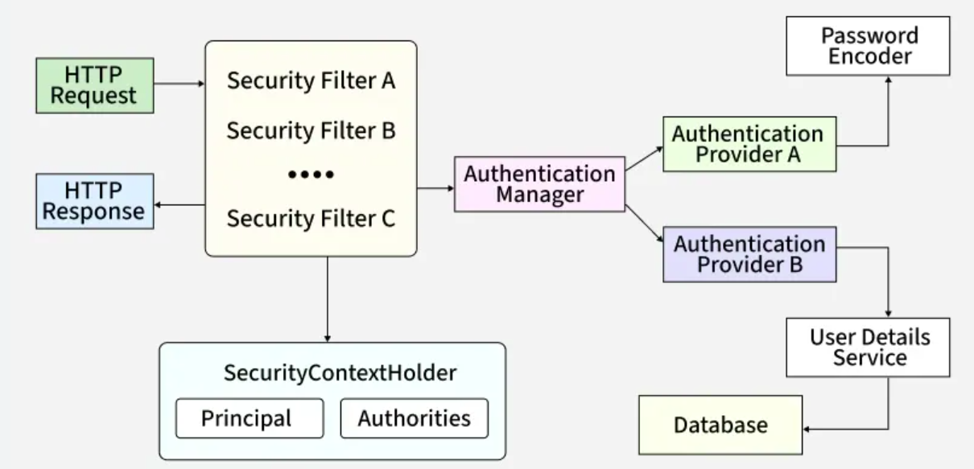

Task 8: What is a Security filter chain? Give example code

Security Filter Chain is the sequence of security filters that intercept every HTTP request before it reaches the application. It performs tasks such as authentication, authorization, CSRF protection, and request validation.

@Configuration
@EnableWebSecurity
public class SecurityConfig {

@Bean
public SecurityFilterChain securityFilterChain(HttpSecurity http) throws Exception {
http
.authorizeHttpRequests(auth -> auth
.anyRequest().authenticated()
)
.formLogin();

return http.build();
}
}

This configuration secures all requests and requires users to log in before accessing any endpoint.

Task 9: What is an Authentication Manager? Give example code

AuthenticationManager is the core Spring Security component responsible for verifying a user's credentials (such as username and password). If authentication is successful, it returns an authenticated user object; otherwise, it throws an exception.

@Bean
public AuthenticationManager authenticationManager(
AuthenticationConfiguration config) throws Exception {
return config.getAuthenticationManager();
}

This bean provides the AuthenticationManager, which Spring Security uses to authenticate users during login.

Task 10: What are Authentication Providers? Give example and code

AuthenticationProvider is a Spring Security component that verifies a user's credentials (such as username and password). It is called by the AuthenticationManager to authenticate users using a specific mechanism, such as an in-memory user store, database, or LDAP.

// AuthenticationProvider
@Bean
public DaoAuthenticationProvider authenticationProvider() {

DaoAuthenticationProvider provider =
new DaoAuthenticationProvider();

provider.setUserDetailsService(userDetailsService());
provider.setPasswordEncoder(passwordEncoder());

return provider;
}

// AuthenticationManager
@Bean
public AuthenticationManager authenticationManager() {

return new ProviderManager(authenticationProvider());
}
Here, DaoAuthenticationProvider authenticates users by loading their details from a database (through UserDetailsService) and comparing the entered password using the configured PasswordEncoder.

Task 11: What is USerDeatilsService? Give example

UserDetailsService is a Spring Security interface used to load user details (username, password, and roles) from a database, memory, or another source during authentication. It is called by the AuthenticationProvider to verify the user's credentials.

@Bean
public UserDetailsService userDetailsService() {
UserDetails user = User.builder()
.username("bhargav")
.password(passwordEncoder().encode("1234"))
.roles("USER")
.build();

return new InMemoryUserDetailsManager(user);
}

Flow: AuthenticationManager → AuthenticationProvider → UserDetailsService → User Details

Task 12: What is a Password encoder? Give example

A PasswordEncoder is a Spring Security interface used to encrypt (hash) passwords before storing them and to verify the entered password during login. It helps protect user passwords from being stored in plain text.

@Bean
public PasswordEncoder passwordEncoder() {
return new BCryptPasswordEncoder();
}

Usage:
String encodedPassword = passwordEncoder().encode("1234");

Task 13: What is SecurityContextHolder?

SecurityContextHolder is a Spring Security class that stores the currently authenticated user's details in a SecurityContext. It allows any part of the application to access information about the logged-in user.

Authentication auth = SecurityContextHolder.getContext().getAuthentication();
System.out.println(auth.getName()); // Logged-in username

Flow: User Login → Authentication → SecurityContextHolder → Current User Details

Task 14: Finally give the security Architecture internal functionality? How actually it works internally… step by step if you can explain

Step 1: Client sends Request

Step 2: Security Filter Chain intercepts the request

Before the request reaches your controller, it is intercepted by the SecurityFilterChain.

@Bean
SecurityFilterChain securityFilterChain(HttpSecurity http) throws Exception {

http.authorizeHttpRequests(auth ->
auth.anyRequest().authenticated())
.httpBasic(Customizer.withDefaults());

return http.build();
}

Step 3: AuthenticationManager is called

If the user is not authenticated, the filter delegates the request to the AuthenticationManager.

AuthenticationManager itself does not verify usernames or passwords.

Its only job is to delegate authentication to an appropriate AuthenticationProvider.

Step 4: AuthenticationProvider verifies credentials

@Bean
AuthenticationProvider authenticationProvider(){

DaoAuthenticationProvider provider =
new DaoAuthenticationProvider();

provider.setUserDetailsService(userDetailsService());
provider.setPasswordEncoder(passwordEncoder());

return provider;
}

Responsibilities:
- Loads the user
- Checks the password
- Returns success or failure

Step 5: UserDetailsService loads the user

The AuthenticationProvider calls:

@Bean
UserDetailsService userDetailsService(){

UserDetails user = User.builder()
.username("bhargav")
.password(passwordEncoder().encode("1234"))
.roles("USER")
.build();

return new InMemoryUserDetailsManager(user);
}

It loads:
- Username
- Password
- Roles

Step 6: PasswordEncoder verifies password

Spring never compares plain text passwords.

PasswordEncoder encoder = new BCryptPasswordEncoder();
encoder.matches(rawPassword, encodedPassword);

Step 7: Authentication object is created

Spring creates an Authentication object.

It contains:
- Username
- Roles
- Authorities
- Authentication status

Step 8: Store authentication in SecurityContextHolder

Spring stores the logged-in user information.

SecurityContextHolder
.getContext()
.setAuthentication(authentication);

Use anywhere in your application
Authentication auth = SecurityContextHolder.getContext().getAuthentication();
System.out.println(auth.getName());

Overall Flow Diagram

Client Request
|
▼
SecurityFilterChain
|
▼
AuthenticationManager
|
▼
AuthenticationProvider
|
▼
UserDetailsService
|
▼
Database / In-Memory User
|
▼
PasswordEncoder
|
▼
Authentication Successful
|
▼
SecurityContextHolder
|
▼
Controller
|
▼
Response

Task 15: What is Thymeleaf? Explain? Why is it used?

Thymeleaf is a server-side Java template engine used with Spring Boot to create dynamic web pages. It allows developers to display data from the backend directly in HTML using special Thymeleaf attributes.
It integrates seamlessly with Spring Boot, making it easy to build MVC applications by rendering dynamic HTML pages, handling forms, and displaying data from controllers.

Example:
<h2 th:text="${username}"></h2>

Here, ${username} is replaced with the value sent from the Spring Boot controller.

Task 16: Create a demo on thymeleaf.

Task 17: What do you think are the advantages of using thymeleaf?

Thymeleaf integrates seamlessly with Spring Boot and allows developers to create dynamic HTML pages using data from the backend. It supports natural HTML templates that can be opened directly in a browser, making development and testing easier while keeping the UI clean and maintainable.

Task 18: What is Caching in Springboot?

Caching in Spring Boot is a technique used to store frequently accessed data in memory, so repeated requests can be served quickly without querying the database every time. It improves application performance, reduces database load, and decreases response time.

@Cacheable("customers")
public List<Customer> getCustomers() {
return customerRepository.findAll();
}

Task 19: What are the features of Caching?

Caching stores frequently accessed data in memory, providing faster data retrieval and reducing the number of database or API calls. It improves application performance, lowers server load, and decreases response time for repeated requests.

Task 20: What are the types of Caching ?explain each type.

Types of Caching in Spring Boot:

1. In-Memory Cache

Stores data in the application's memory (RAM). It is very fast and is suitable for small or standalone applications. Examples include ConcurrentHashMap and Caffeine.

2. Distributed Cache

Stores cached data in a separate cache server that can be shared across multiple application instances. It is ideal for microservices and clustered applications. Examples include Redis and Hazelcast.

3. Disk-Based Cache

Stores cached data on the local disk instead of memory. It can hold larger amounts of data but is slower than in-memory caching. An example is Ehcache configured with disk persistence.

4. Database Cache

Stores frequently accessed query results or data within the database or an intermediate caching layer. It helps reduce repeated database queries and improve performance.

5. HTTP/Web Cache

Caches HTTP responses so repeated client requests can be served without reprocessing on the server. It is commonly used by browsers, CDNs, and proxy servers using cache headers such as Cache-Control and ETag.

Task 21: List down annotations of Caching with usage.

- @EnableCaching
Enables caching support in a Spring Boot application. It is added to the main configuration or application class.

@EnableCaching
@SpringBootApplication
public class DemoApplication { }

- @Cacheable
Caches the result of a method. If the same request is made again, the cached result is returned instead of executing the method.

@Cacheable("customers")
public List<Customer> getCustomers() { ... }

- @CachePut
Updates the cache whenever the method is executed. The method always runs, and the cache is refreshed with the latest value.

@CachePut(value = "customers", key = "#customer.id")
public Customer updateCustomer(Customer customer) { ... }

- @CacheEvict
Removes data from the cache. It is commonly used after deleting or modifying data.

@CacheEvict(value = "customers", key = "#id")
public void deleteCustomer(Integer id) { ... }

- @Caching
Allows multiple caching annotations (@Cacheable, @CachePut, @CacheEvict) to be applied to the same method.

@Caching(
evict = { @CacheEvict(value = "customers", key = "#id") }
)
public void removeCustomer(Integer id) { ... }

- @CacheConfig
Defines common cache settings (such as cache names) at the class level, avoiding repetition on every method.

@CacheConfig(cacheNames = "customers")
@Service
public class CustomerService { }

Task 22: What do you think @InjectMocks annotation does?

@InjectMocks is a Mockito annotation that creates an instance of the class under test and automatically injects all @Mock dependencies into it. It eliminates the need to manually create the object and pass mocked dependencies through the constructor or setters.

Example:
@Mock
private BankRepo bankRepo;

@InjectMocks
private BankService bankService;

Here, Mockito creates a BankService object and automatically injects the mocked BankRepo into it.

Task 23: Write about @spy annotation and explain the functionality in a small piece of code

@Spy is a Mockito annotation that creates a partial mock of a real object. It calls the actual methods by default, but you can stub or verify specific methods when needed.

class Calculator {
int add(int a, int b) {
return a + b;
}
}

@Spy
Calculator calculator = new Calculator();

@Test
void testAdd() {
assertEquals(5, calculator.add(2, 3)); // Calls real method
verify(calculator).add(2, 3); // Verifies method invocation
}

Here, @Spy uses the real Calculator object, executes the actual add() method, and also allows Mockito to verify that the method was called.

Task 24: Why is @Mock annotation used?

@Mock is a Mockito annotation used to create a fake (mock) object of a dependency during unit testing. It isolates the class under test by avoiding calls to real databases, APIs, or external services, making tests faster and more reliable.

@Mock
private BankRepo bankRepo;

Here, bankRepo is a mock object, allowing you to define its behavior using when() and verify interactions using verify().

Task 25: What is Partial mocking? Which annotation is used for partial mocking?

Partial mocking means using the real implementation of an object while mocking only selected methods. It is useful when you want to test most of the actual behavior but override specific methods.

The @Spy annotation is used for partial mocking.

@Spy
Calculator calculator = new Calculator();
Here, real methods are executed by default, but specific methods can be stubbed or verified using Mockito.

Task 26: For the code given what is @verify annotation used for and why do we use it?

verify() is a Mockito method used to check whether a mock object's method was called during the test and how many times it was called. It helps ensure that your code interacts with its dependencies as expected.

verify(bankRepo).save(account); // Confirms save() was called once

Task 27: List down a few more annotations that we use for mocking ..

- @Mock – Creates a mock (fake) object for testing dependencies.
- @InjectMocks – Creates the class under test and injects all mock dependencies automatically.
- @Spy – Creates a partial mock that calls real methods unless stubbed.
- @Captor – Captures method arguments passed to mock objects for verification.
- @ExtendWith(MockitoExtension.class) (JUnit 5) – Enables Mockito annotations like @Mock and @InjectMocks in JUnit 5 tests.

